Urban Debate League Curriculum: October 2016 – Electoral College

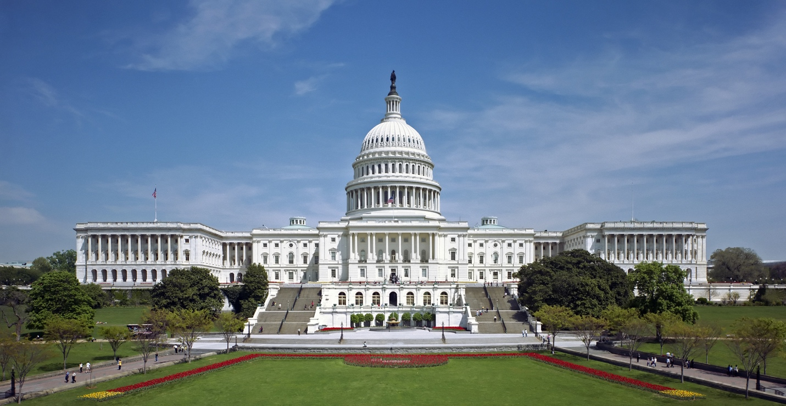

Week 1 – Background and Debrief
- Debrief of the tournament and how the weekend was (10-15 min)
- What we can improve on for future tournaments (5 min)
- Discussion time on the topic (25 min)
  - Some questions to get started
    - What is the electoral college?
    - What is the purpose of our elections and the electoral college?
    - What is the history behind the creation of the electoral college?
      - Was written in to the constitution when large states and small states came into conflict about their representation in Congress
    - How would our voting processes differ if we didn’t have the electoral college and we instead had a popular vote?
    - What are some examples of popular votes in your lives? Student government, team captains, etc.

Week 2 – Framing
- Framing Background! (20 min)
  - Ask the kids impact comparison questions like, what’s more valuable, life or money?
  - Challenge them to challenge absolutes – usually they’ll say life is more important which is the obvious answer
    - Ask if it’s possible to value human life in dollar terms.
    - Give examples of where it has been necessary to do so – life insurance, military action, etc.
    - Would the government pay an infinite sum of money to save one person’s life? No – is that justified?
  - Ask them to compare fundamental world views
    - Comparison between security and privacy (think NSA/Domestic surveillance)
    - Religious rights versus individual rights
  - Use those comparisons to lead into a discussion of framing
  - Tell them that there is a formal mechanism in debate to establish these types of “frameworks” or world views
  - If you argue the framework, the judge has to judge on your world view – becomes helpful when you have comparisons between two distinctly different impacts
- Framing generation on the topic (20 min)
  - Use this topic: This House Believes that the Electoral College harms American democracy.
  - The two frameworks that should come up should be based on the protection of minority rights (state’s rights usually) and the value of each person’s independent vote.
  - Have them come up with reasons why their framework is true – usually includes linking back to the operative words which in this case is “harms” and “American democracy”
- Argument generation (20 min)
  - Have them give their different frameworks
  - And have them argue against each other
    - They should be flowing as well

Week 3 – Workshopping Skills
- Flowing! (25 min)
  - Use the resolution above
  - Have the kids make a case for the Gov or Opp side with only 1-2 points. Give them 10 mins prep.
  - Have them speak, have people flow, and then pick a few students to give their Opp case and respond to the first case
  - This entire time, emphasize correct flowing technique – whatever works for you but I usually do two separate sheets of paper, one with the Gov and one with the Opp cases and have two colors of ink.
  - Look at their flows and see where they can improve!
- Enunciation (10 min)
  - Have the kids pull out a book, a worksheet, or something they can read off of.
  - Demonstrate for them how enunciation sounds while speaking
    - Be very deliberate in your words, overemphasize tongue and mouth movements
  - Have them each practice (can split off into groups or keep groups together, up to you)
- Fluency and flow drills – this flow means how well they can speak continuously
  - Ask them to prep an impromptu speech (1 min speech with 30 seconds prep time)
  - It can be on anything
  - Have them write a few notes but not enough for a full speech
  - And then have them give the 1 min speech
- Game (10 min)
  - Debate baseball, mine is bigger (this is a link to more games if you want to see them)

Week 4 – PRACTICE!
- Have a practice round (two if possible running at the same time, or more if you have the ability)
- Use one of the following resolutions:
  - THBT, on balance, the Electoral College disenfranchises American citizens.
  - THW abolish the Electoral College.
  - THBT the Electoral College system harms the United States.

